**Software Training plan**

**Asana**

Shreyas Dutt

University of the Fraser Valley

CIS-285: End User Training and Support

Professor Anoop Saxena

Due Date: 20th November 2023

Contents

**Introduction:** 4

**Company** 4

**Software:** 4

**Environment Setting:** 4

**Audience:** 5

**Objective:** 5

**Training Program Structure** 6

**Session 1: Introduction to Asana and Basic Navigation** 6

**Session 2: Task and Project Management in Asana** 6

**Session 3: Advanced Features and Troubleshooting** 7

**Training** 8

**Creating an Asana account:** 8

**Downloading Asana:** 9

**Setting-up your Asana Profile:** 11

**Asana Homepage:** 13

**My Tasks** 14

**Inbox** 17

**Reporting** 19

**Portfolios** 22

**Goals** 24

**Creating a Goal:** 24

**Editing a Goal:** 26

**Creating a Project & Tasks:** 27

**Creating a Task in a project:** 31

**Assigning a task to multiple users** 33

**Different views offered by Asana:** 34

**Adding members to a project:** 34

**Setting task dependencies:** 35

**Adding Attachment and a comment:** 36

**Adding tags to a task:** 37

**Adding a subtask:** 38

**Integrating an App:** 39

**Notifications:** 40

**Common Issues and Troubleshooting:** 41

**Summary:** 47

**Additional Resources/References** 47

**References:** 48

**Key Performance Indicators:** 49

**Table of Figures**

Figure 1 9

Figure 2 10

Figure 3 11

Figure 4 12

Figure 5 12

Figure 6 13

Figure 7 14

Figure 8 15

Figure 9 15

Figure 10 16

Figure 11 16

Figure 12 17

Figure 13 17

Figure 14 18

Figure 15 18

Figure 16 19

Figure 17 20

Figure 18 20

Figure 19 21

Figure 20 21

Figure 21 22

Figure 22 22

Figure 23 23

Figure 24 24

Figure 25 24

Figure 26 25

Figure 27 26

Figure 28 26

Figure 29 27

Figure 30 28

Figure 31 Figure 32 28

Figure 33 29

Figure 34 29

Figure 35 30

Figure 36 30

Figure 37 31

Figure 38 32

Figure 39 32

Figure 40 33

Figure 41 33

Figure 42 34

Figure 43 35

Figure 44 35

Figure 45 36

Figure 46 36

Figure 47 37

Figure 48 38

Figure 49 39

Figure 50 39

Figure 51 40

Figure 52 41

Figure 53 41

Figure 54 42

Figure 55 43

Figure 56 43

Figure 57 44

Figure 58 44

Figure 59 45

# **Introduction:**

**Company:**

Hatch Works is a leading software solutions provider based in Atlanta, Georgia, USA. They specialize in creating custom software solutions for businesses and organizations. Their services include Business Intelligence (BI) and Big Data consultation, UX/UI Design services, and Artificial Intelligence (AI) development. With a team of experienced professionals, they help companies achieve their business goals through technology.

## **Software:**

Asana is a popular team management software that is widely used by companies to streamline their daily tasks. It enables team members to collaborate effectively, thereby helping them achieve their organizational objectives. With Asana, teams can assign tasks to specific members, track progress, and manage time and tasks efficiently. By enhancing productivity and collaboration, Asana offers a comprehensive solution for team management.

## **Environment Setting:**

In this training plan, we will focus on utilizing Asana, a team management software that is widely used by companies for optimizing day-to-day tasks and collaboration. Asana is a cloud-based platform that helps teams manage projects, tasks, and workflows. It allows team members to assign tasks, track progress, and communicate effectively.

## **Audience:**

The target audience for this training program includes employees and team members at HatchWorks who are responsible for task management, project collaboration, and improving overall productivity. The training is designed for beginners who may not be familiar with Asana or want to deepen their knowledge. The course will cover the basics of Asana, including setting up projects, creating tasks, assigning tasks, tracking progress, and communicating with team members.

## **Objective:**

This training program aims to equip participants with comprehensive knowledge of Asana, enabling them to utilize the software in a professional setting to enhance task organization, collaboration, and productivity. Ultimately, this will aid them in achieving their organizational objectives.

Upon completion of the program, participants will be able to:

* Understand Asana's fundamental features.
* Efficiently create, assign, and organize tasks to optimize workflow.
* Apply Asana for daily task management.
* Utilize timelines and calendars to visually track project schedules and deadlines.
* Seamlessly integrate Asana with other business tools to boost productivity.

# **Training Program Structure**

This training program will be organized into three sessions, each spanning a duration of two hours. Each session will cover the following topics:

## **Session 1: Introduction to Asana and Basic Navigation**

* Introduction to HatchWorks and Asana
* Overview of Asana as a team management software
* Setting up an Asana account
* Downloading Asana on different platforms
* Setting up Asana profile
* Navigating the Asana homepage
* Understanding "My Tasks" and its views (List, Board, Calendar)
* Exploring the "Inbox" for task notifications
* Overview of Asana's reporting features

## **Session 2: Task and Project Management in Asana**

* Creating projects in Asana (using templates, importing spreadsheet, creating from scratch)
* Creating tasks within a project
* Assigning tasks to team members
* Setting due dates and priorities for tasks
* Different views offered by Asana (List, Board, Calendar, Timeline)
* Adding members to a project
* Setting task dependencies
* Attaching files and adding comments to tasks
* Adding tags and subtasks to tasks

## **Session 3: Advanced Features and Troubleshooting**

* Introduction to Asana Portfolios and Goals
* Creating and editing goals in Asana
* Managing multiple projects using Portfolios
* Integrating external apps with Asana
* Configuring and customizing Asana notifications
* Common issues and troubleshooting (login problems, task/project management challenges, performance issues)
* Recovering deleted tasks in Asana
* Summary and review of key concepts covered in the training program.

# **Training**

## **Creating an Asana account:**

Open your web browser and search for <https://asana.com/>.

Click on the Get started button, which will redirect to asana’s login page.

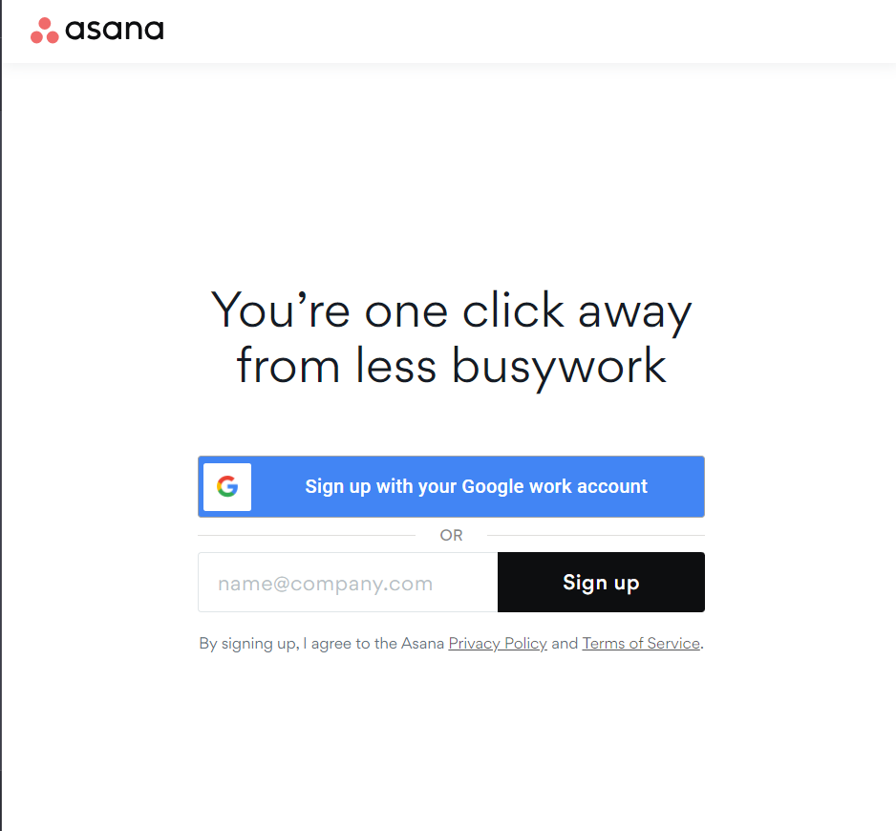

Figure

Choose your Sign-up Option.

Sign up with Google or use your email ID to sign up.

After signing in complete the sign-up form which includes your full name, your role and your preferences related to the UI.

## **Downloading Asana:**

After Signing up you can access asana from different platforms:

1. Web Application: Asana's web-based platform can be accessed through your browser.
2. Windows Application: There's a dedicated Asana application for Windows users.
3. Mobile Apps: Asana offers mobile applications for both Android and iOS devices.

To download Asana visit: <https://asana.com/download>

Figure

Download the appropriate version of Asana that matches your specific operating system or device.

For Windows systems first check system architecture:

1. Open cmd
2. Type in this command: wmic os get osarchitecture.

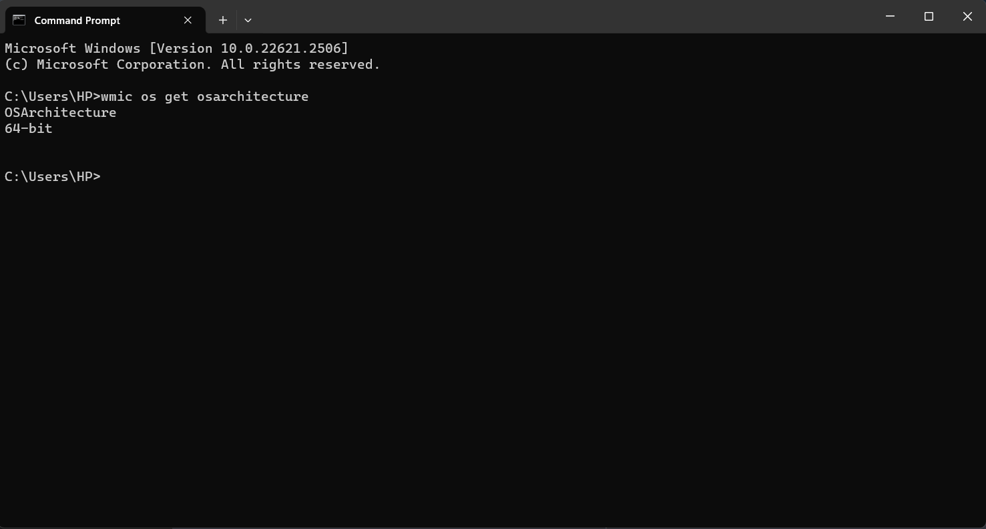

Figure

1. Download accordingly.

## **Setting-up your Asana Profile:**

* Click on your profile picture or name.

Figure

* Select "Edit Profile".

Figure

Modify your profile information, including:

Figure

* Update your profile picture.
* Change your name.
* Edit your email.
* Set your time zone.
* Choose your preferred language.
* Customize notification preferences.
* Add or update your bio.
* Adjust your job title.
* Link connected accounts.
* Click the "Save Profile" button to save your changes.
* Explore additional settings like email signature, export options, and data sharing preferences.

## **Asana Homepage:**

**Home** is a feature that allows you to easily navigate and access your Asana dashboard. With Home, you can quickly view your tasks, projects, and conversations, as well as create new tasks and projects directly from the dashboard.

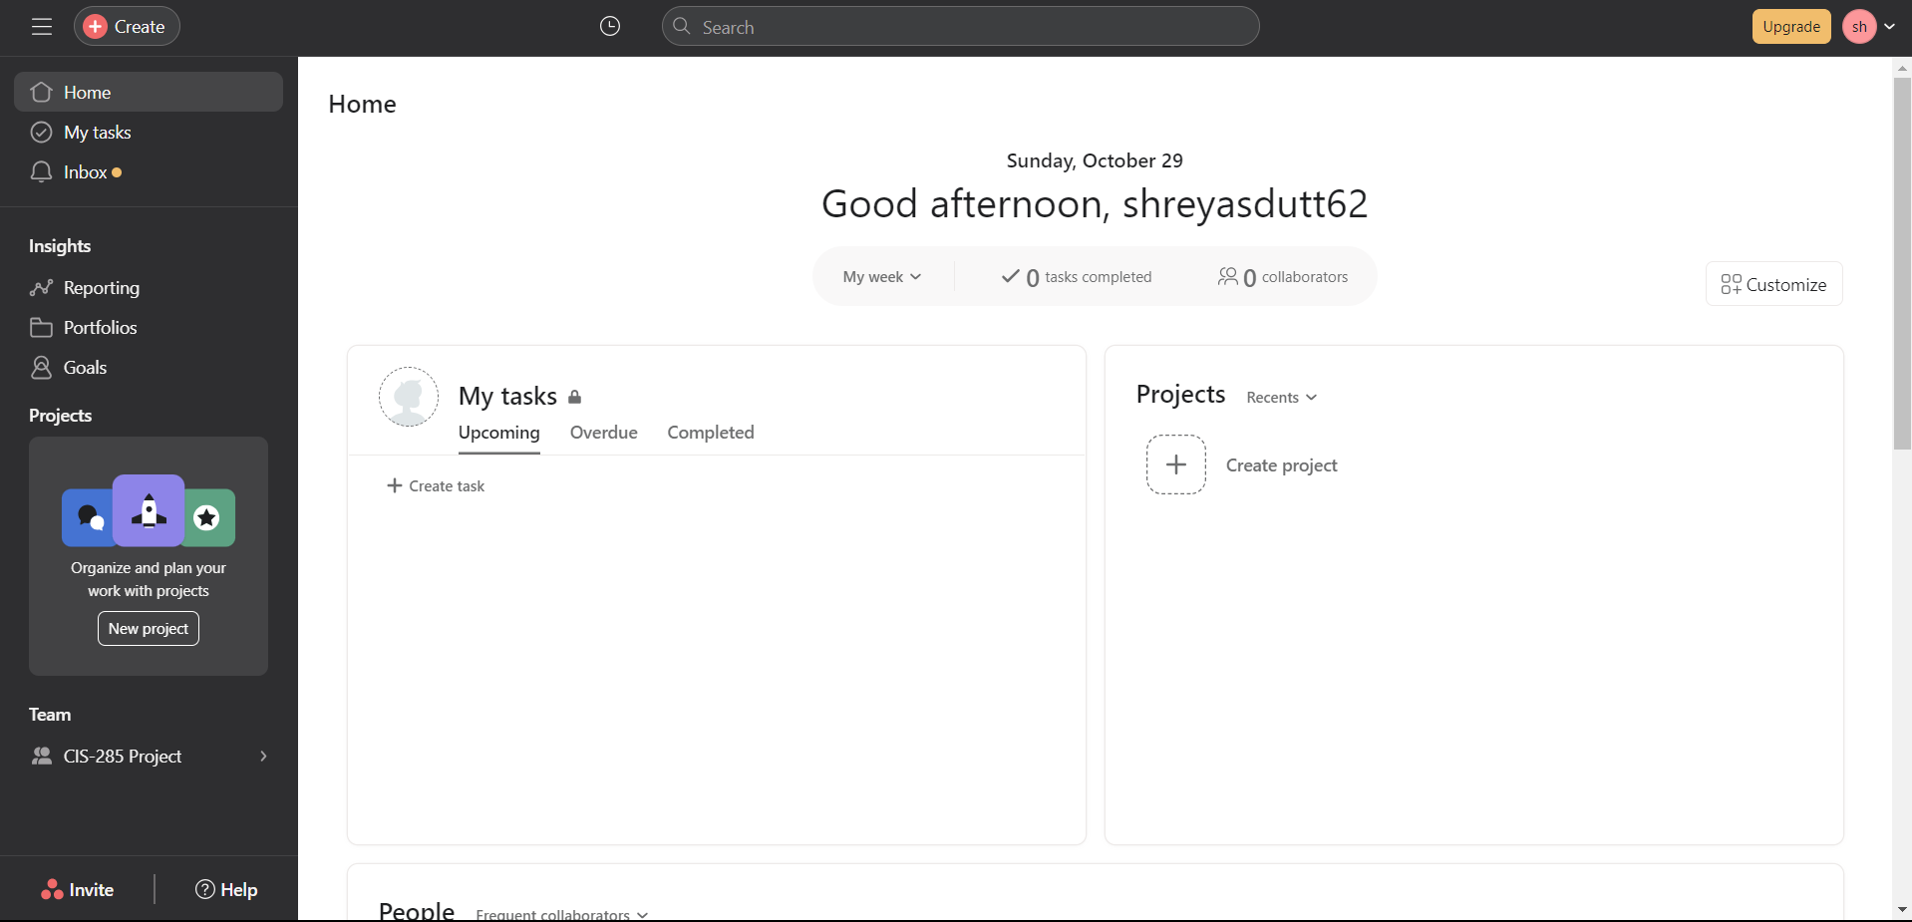

Figure

**My Tasks**

My tasks feature displays your assigned tasks, due dates, and priority levels. Stay organized and plan your work effectively to meet deadlines. Set reminders and alerts to stay on track. An essential tool for productivity.

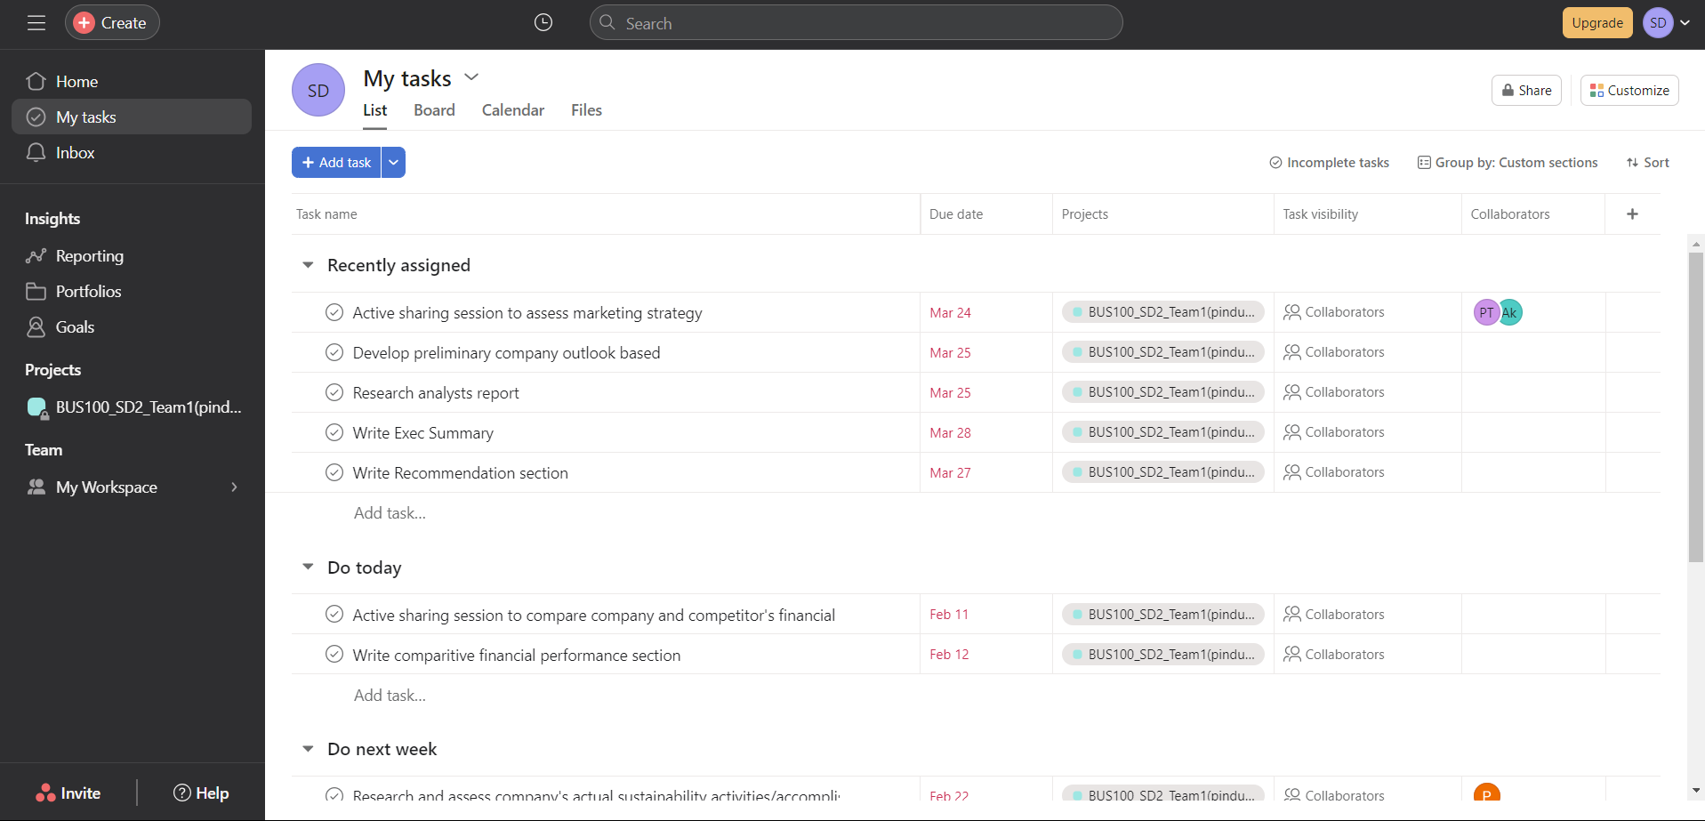

Figure

Here, you can observe your tasks in multiple views to enhance your experience.

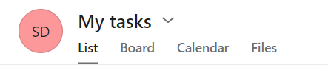

Figure

In Asana, you have a total of three views: List, Board, and Calendar.

List view (default view)

Figure

Board view

Figure

Calendar view

Figure

Lastly, the Files section consolidates all attachments from your tasks and messages within a specific project, providing a centralized location for easy access.

Figure

## **Inbox**

Inbox displays notifications for tasks, conversations, and projects.

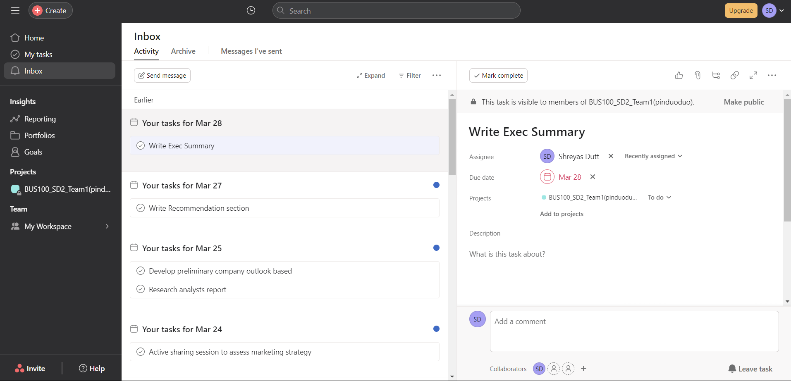

Figure

**To send a message**, click on "Send message" at the top left of the panel.

Figure

A new dialog box will appear; enter the recipient's address, compose the message, and click send.

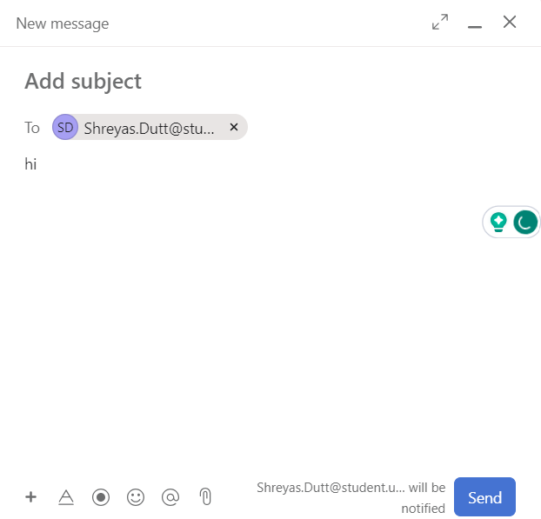

Figure

## **Reporting**

Reporting feature through its Insights functionality, which allows for the creation of detailed reports on projects and tasks.

To access Reporting, navigate to the left sidebar and click on the "Reporting" option.

Figure

To create a Report, click on create located at the top-left corner.

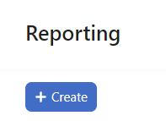

Figure

Upon clicking "Create," you will be directed to this screen, here you can choose the desired chart views for your report.

Figure

Click "Add custom chart" to create and customize a personalized chart according to your preferences.

Figure

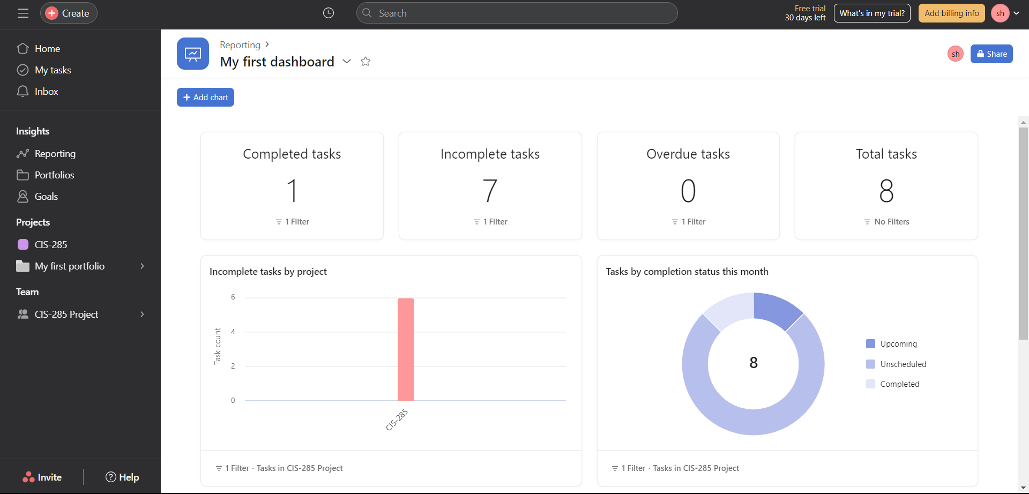

Figure

* The "Add Chart" button enables you to view various types of performance-related data on a single page.
* You have the flexibility to add multiple charts, customize them with different colors, labels, and data ranges, enhancing your ability to analyze data more effectively.

Figure

## **Portfolios**

Portfolios feature helps users manage multiple projects at once. This feature is particularly helpful for managers overseeing multiple teams or individuals working on several projects simultaneously.

To access Portfolios, navigate to the left sidebar and click on the "Portfolios" option.

Figure

Figure

Using the "Portfolios" option, you can efficiently view all projects in a well-organized manner, facilitating seamless navigation from one project to another**.**

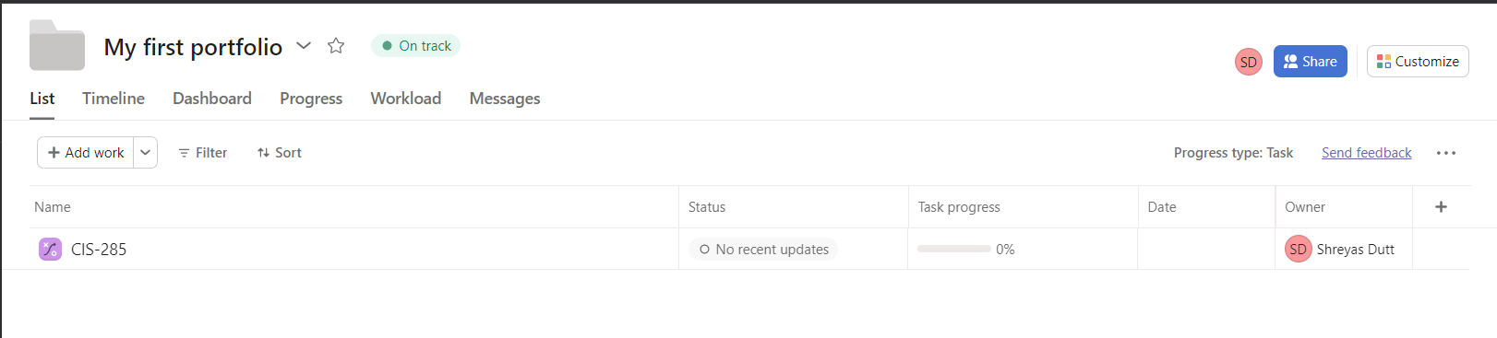

Figure

## **Goals**

Goalsallow users to set objectives and track their progress towards achieving them. With this feature, users can create specific and measurable goals, assign them to team members, and monitor their progress through regular updates.

## **Creating a Goal:**

To establish a Goal, begin by navigating to the "Goals" section in the left side panel.

Figure

Next, input the Goal title, designate the Goal Owner, specify the time period for the Goal, and add the members associated with the Goal and click “Save Goal” to create the goal.

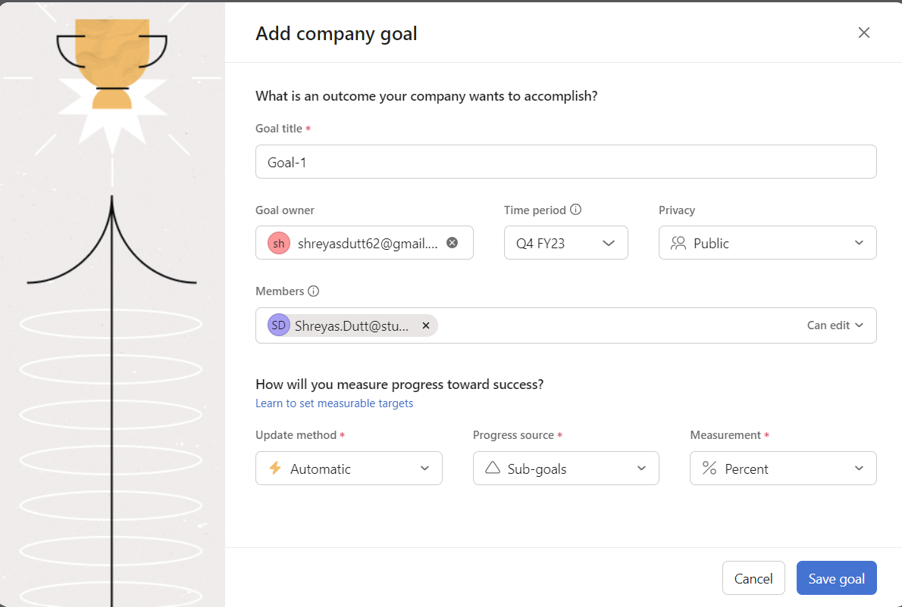

Figure

After creating a Goal, your window will look like this:

Figure

## **Editing a Goal:**

Place your cursor over the progress bar, and then select "Edit progress settings."

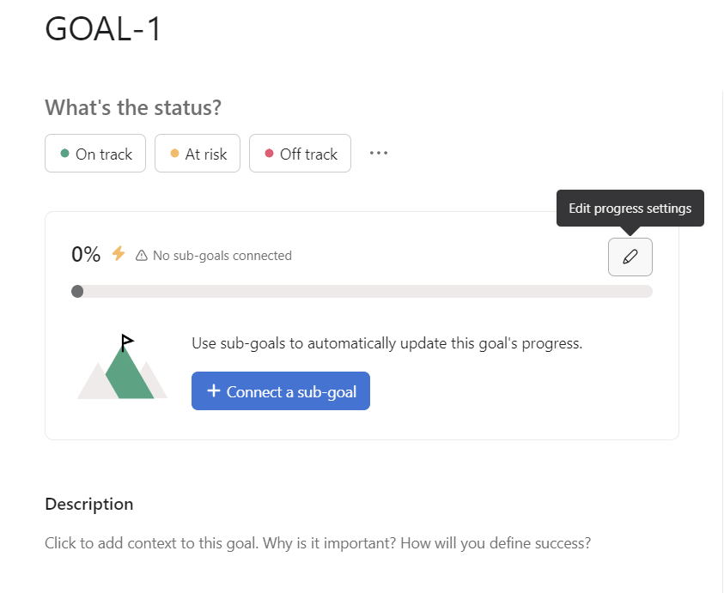

Figure

Within the "Edit progress settings," you have the flexibility to adjust various configurations, allowing you to customize the goal according to the specific preferences and requirements of the user.

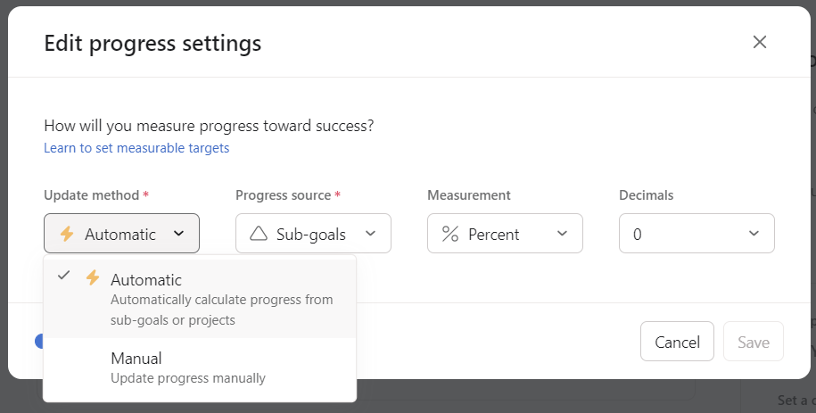

Figure

## **Creating a Project & Tasks:**

Once you're in the "Projects" section, click the "+ Create Project" button, typically located at the top right of the page.

Figure Figure

Creating a project in Asana offers multiple methods, and one of the simplest ways is to utilize a template. Click on "Use a template" to choose from a diverse range of templates provided by Asana.

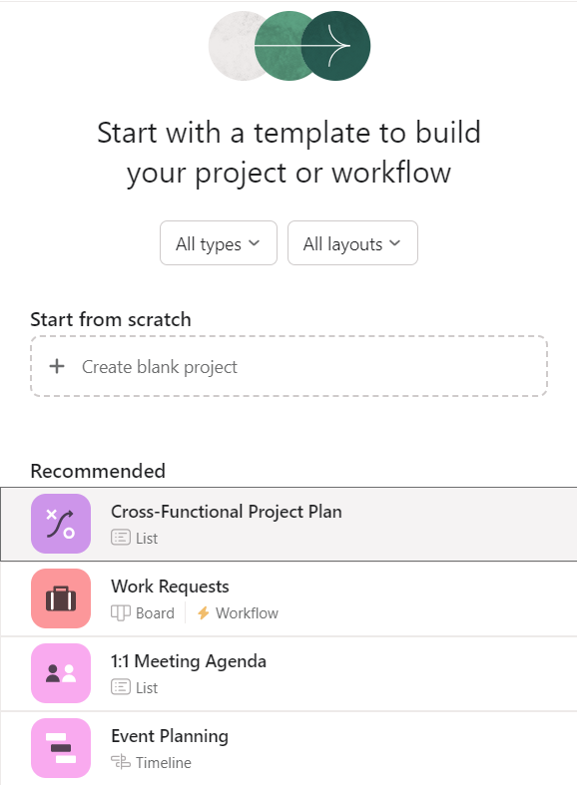

Figure

An alternative method for creating a project is by utilizing a CSV file; click on "Import spreadsheet."

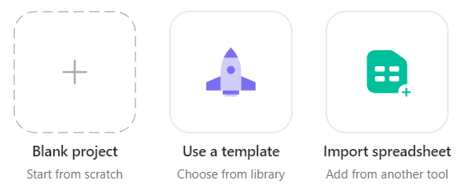

Figure

Provide a name for your project, then select and proceed with the CSV file.

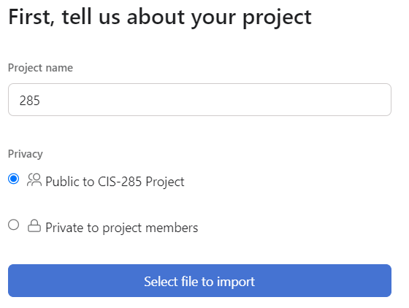

Figure

This action will add tasks based on the rows and columns specified in the CSV file.

Figure

Lastly the 3rd way of Creating a project is to build it from scratch, click on “Blank Project-create from scratch”.

Figure

## **Creating a Task in a project:**

Figure

* To create a task in a project, click on the Add task button.
* Give a name to your task.

Figure

To assign a task in Asana, click "Assign" and choose the team member.

Figure

To add a due date, click the date field, select a date, and save the task.

Figure

To set task priority in Asana, open the task details and select the priority level (e.g., high, medium, low) from the priority section.

Here is a Video Tutorial on how to create tasks and subtasks: <https://drive.google.com/file/d/1OiOPSzoDHZYeiCjdUBSlFea6eygQWRdH/view?usp=sharing>

## **Assigning a task to multiple users**

To assign a task to multiple individuals, navigate to the task details, click on "Assignee," and select the option to assign the task to multiple people.

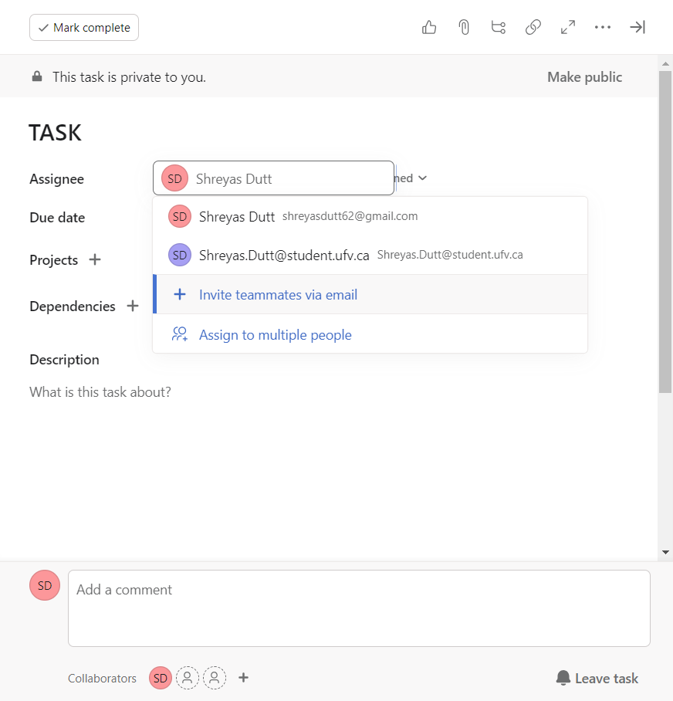

Figure

Proceed to add the desired users. This action will generate a duplicate task assigned to the newly added individuals.

Figure

## **Different views offered by Asana:**

* List View: Provides a traditional task list layout, ideal for detailed task management and to do lists.
* Board View: Organizes tasks in columns, making it great for visual project progress tracking.
* Calendar View: Displays tasks and deadlines in a calendar format, offering a clear overview of time sensitive tasks.
* Timeline View: Offers a visual timeline of tasks and their dependencies.

Figure

## **Adding members to a project:**

To invite a member to the project, navigate to the "Overview" section within the project and click on "Add Member." Enter the recipient's email address to send an invitation link.

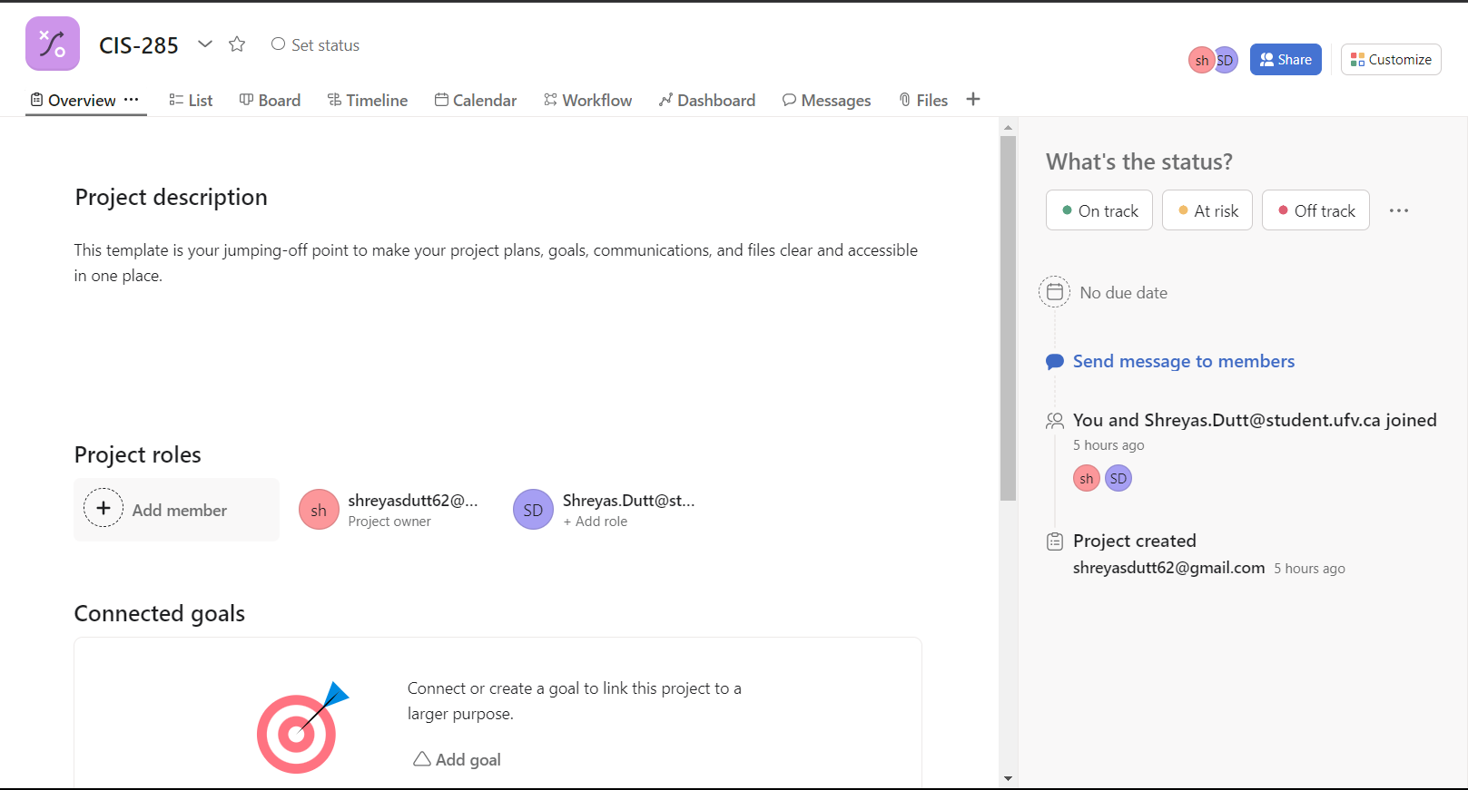

Figure

Figure

## **Setting task dependencies:**

* Open the task.
* Find and select "Add Dependency."
* Choose the task(s) that the current task depends on.
* Save the dependencies.

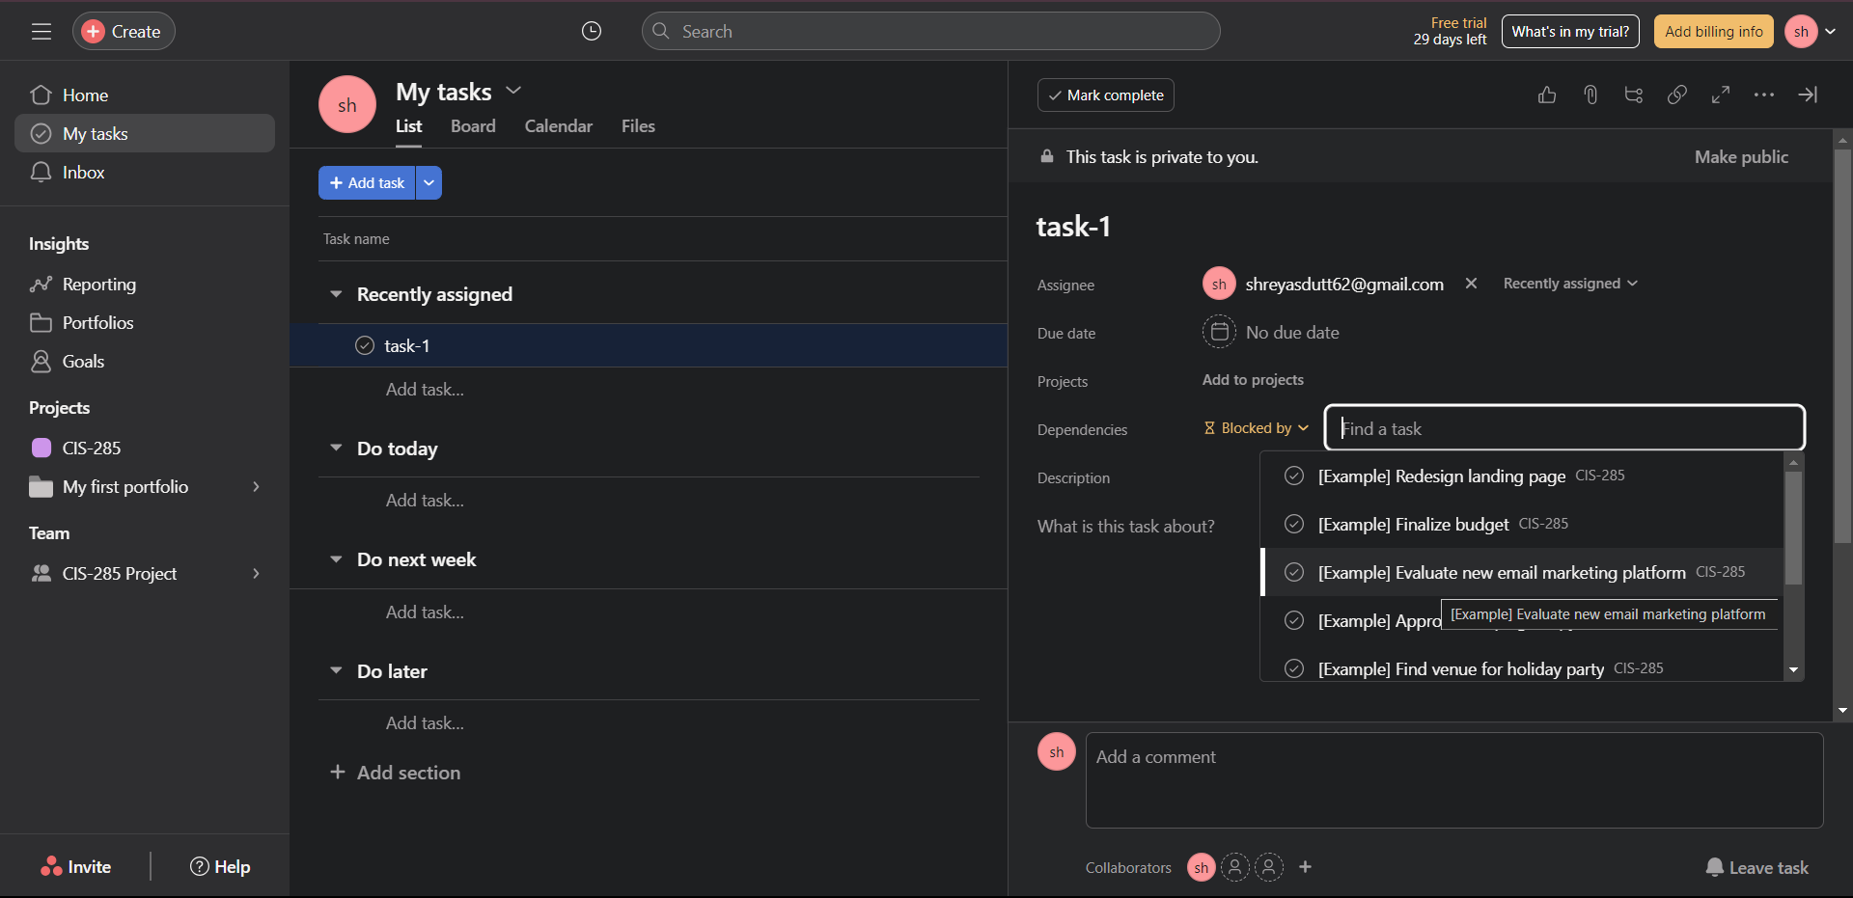

Figure

## **Adding Attachment and a comment:**

* Attachments: Click "Add Attachment" to upload files or link to cloud storage.
* Comments: Type your comment in the comments section and use "@" to mention team members.

Figure

## **Adding tags to a task:**

* Select the task and add relevant tags under "Tags" or "Labels".

Figure

## **Adding a subtask:**

* Open a task.
* Find the "Subtasks" section.
* Click "Add Subtask" and enter details.
* Assign subtask to team members, set due dates, and specify priorities.
* Save subtasks.

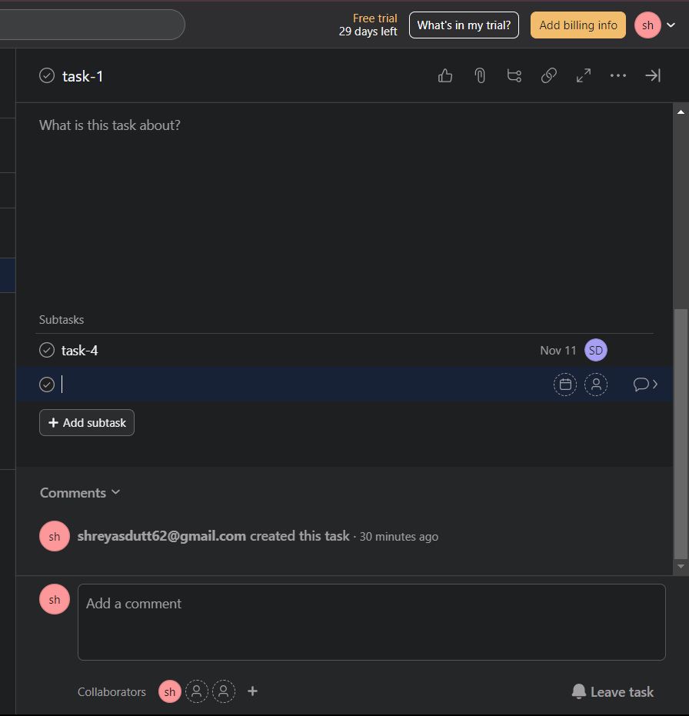

Figure

## **Integrating an App:**

* To access Asana integrations, go to "My Tasks" and click "Customize".
* Select "Apps", choose the integration you want to use and follow the installation instructions.

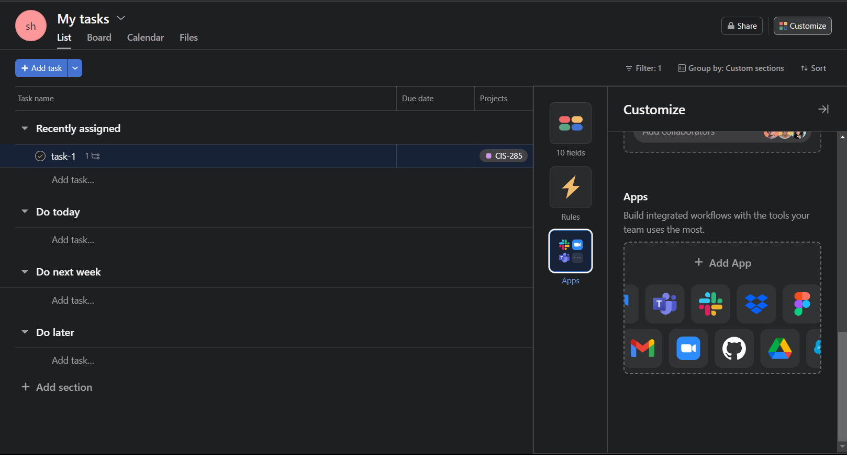

Figure

Figure

## **Notifications:**

To adjust your Asana notification settings, follow these steps:

* Click your profile icon in the top-right corner.
* Select "Settings".
* Scroll down to "Notifications".
* Customize your notification preferences.

Figure

# **Common Issues and Troubleshooting:**

1. **Access and Login Problems:**

Click on the "Forgot Password" link on the Asana login page to reset your password. If the issue persists, contact Asana support at <https://asana.com/support>.

Figure

Figure

2. **Task and Project Management Challenges:**

Follow Asana's task creation guidelines and use project management tools to organize and track your team's progress.

You can find a creation guideline at: <https://help.asana.com/hc/enus/articles/14079133477787-Understanding-tasks>

3. **Performance and Loading Problems:**

Clear browser cache and cookies, check internet connection for stability, and ensure the desktop app is up to date.

To clear your browser's cache and cookies, follow these steps:

* + Go to your browser's settings.
  + Find the privacy and security section.
  + Look for a table or menu where you can clear your browsing data.
  + Select the option to clear your cache and cookies.
  + Confirm the action and wait for the process to complete.

Figure

4. **Recovering Deleted Tasks:**

To recover a deleted task:

1. Click the search button at the top of the home page.

2. Select "Advanced Search."

Figure

Figure

Click on “Add filter”.

Figure

1. Select "More options" and then "Deleted" from the search filter.

Figure

5. Click on "Search" to get the list of all deleted tasks.

6. Find the task you want to restore and click on it.

7. Click on "Undelete" to restore the deleted task.

Figure

# **Summary:**

As part of this comprehensive training program, we have introduced HatchWorks, a software solutions provider, and Asana, a team management software. The main objective of this training is to equip participants with a deep understanding of Asana's core features and how to efficiently use it for task management and project collaboration.

During the training, participants will learn how to create, assign, and organize tasks, set up projects, and manage timelines and calendars. Additionally, they will learn how to use Asana for effective communication and collaboration, including commenting and attaching files to tasks. Enabling the participants to have a comprehensive and practical knowledge of Asana, enabling them to manage tasks, projects, and teams more effectively.

# **Additional Resources/References**

Additional resources and references that can be useful for further exploration beyond the training program:

Asana Help Center: <https://help.asana.com/hc/en-us>

Asana video Tutorials: <https://academy.asana.com/page/video-tutorials>

Asana Support: <https://asana.com/support>

YouTube tutorials for beginners: <https://www.youtube.com/watch?v=jMvuL9qxnd0>

Mastering Asana Tutorials by Paul Minors: <https://shorturl.at/twzW9>

# **References:**

Asana. (n.d.-a). *Asana Support - Help Center • Asana*. Asana. <https://asana.com/support>

Asana. (n.d.-b). *Manage your team’s work, projects, & tasks online • Asana*. Asana. <https://asana.com/>

Paul Minors. (2022a, June 3). *Getting Started with Asana (for Absolute Beginners)* [Video]. YouTube. <https://www.youtube.com/watch?v=pUMCvn8e4CE>

Paul Minors. (2022b, June 24). *10 Asana features you may have missed* [Video]. YouTube. <https://www.youtube.com/watch?v=XNQdrx-pnzc>

*Video tutorials*. (n.d.). Asana Academy. <https://academy.asana.com/page/video-tutorials>

# **Key Performance Indicators:**

Throughout the Training Program, participants will be evaluated on their ability to use Asana through a series of practical exercises, quizzes, and a final project that requires them to apply all the knowledge and skills they have gained. Upon completing this assessment, participants will have the tools and knowledge necessary to utilize Asana for increased productivity and collaboration in their professional environment.

There will be in total 3 Quizzes during the software training:

|  |  |
| --- | --- |
| Quiz 1: Task Basics | * Creating tasks * Task information and details * Due dates * Task dependencies * Task priority levels |
| Quiz 2: Project Management | * Creating projects * Customizing project settings * Adding tasks to projects * Assigning tasks |
| Quiz 3: Collaboration and Communication | * Communication within tasks * Task comments * App Integration * Effective teamwork and collaboration within Asana |